MACH4METAL

metalworking machinery
Transito 21,
6909 DA BABBERICH
Netherlands
Tel. +31 (0)316 – 247123
Fax. +31 (0)316 - 247956
info@mach4metal.com
www.mach4metal.com

Bank No : 66.52.13.883
IBAN : NL33 INGB 0665 2138 83
BIC : INGBNL2A

Yang Eagle SMV 1000 VMC
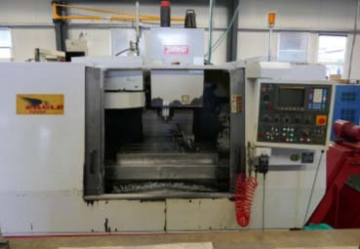
- Make : Yang Eagle
- Type : SMV 1000
- Age : 1998

- Capacity / Working area:

- X - Travel : 1.020
- Y - Travel : 510
- Z - Travel : 510
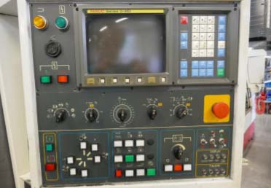
- Table length : 1.070
- Table width : 500
- Table load : 350 Kg

- Spindle : ISO 40
- Speeds : 6.000
- Power : 7.5 kW
- Rapid traverse : 30.000 mm/min

- Fanuc Series 0 -MD
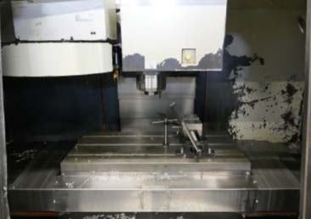
- Chip Conveyor

- Dimensions
- Length : 2.880
- Width : 2.230
- Height : 2.636
- Weight : 4.200

Please Note: The above information has been obtained to the best of our ability and belief from, and from the manufacturers where possible. It is given in good faith, but its accuracy can not be guaranteed. Accordingly, it will not form a representation or constitute contractual terms. We advise you to check any vital details!

